
(Machine Learning & Data Analytics)
SEMESTER 1 (Winter), 2025/2026
Machine Learning – Final Examination Report
NAME: ILYASS LAMBARDI
STUDENT NO.: 202239060075

SUBMITTED TO:
Prof. Ping Li

- Problem Formulation & Data Understanding
- Problem Formulation
- Supervised tabular regression.
- Predict median housing value from neighborhood-level attributes.
- This is treated as a distribution-constrained regression problem, not a predictive benchmark. The dataset is small, skewed, and dominated by a limited subset of variables, making it suitable for analyzing feature dominance, nonlinear interactions, and architecture-dependent inductive bias.
X: Heterogeneous tabular predictors
y: Continuous housing value
Objective: Stable generalization under skewed, interaction-heavy inputs
- Data Understanding:
Content
Each record in the database describes a Boston suburb or town. The data was drawn from the Boston Standard Metropolitan Statistical Area (SMSA) in 1970. The attributes are deﬁned as follows (taken from the UCI Machine Learning Repository1): CRIM: per capita crime rate by town
- ZN: proportion of residential land zoned for lots over 25,000 sq.ft.
- INDUS: proportion of non-retail business acres per town
- CHAS: Charles River dummy variable (= 1 if tract bounds river; 0 otherwise)
- NOX: nitric oxides concentration (parts per 10 million)
1https://archive.ics.uci.edu/ml/datasets/Housing123
- RM: average number of rooms per dwelling
- AGE: proportion of owner-occupied units built prior to 1940
- DIS: weighted distances to ﬁve Boston employment centers
- RAD: index of accessibility to radial highways
- TAX: full-value property-tax rate per $10,000
- PTRATIO: pupil-teacher ratio by town 12. B: 1000(Bk−0.63)2 where Bk is the proportion of blacks by town 13. LSTAT: % lower status of the population
- MEDV: Median value of owner-occupied homes in $1000s
We can see that the input attributes have a mixture of units.

- Dataset Characteristics
- Data type: Structured tabular data
- Granularity: Neighborhood-level aggregates
- Sample size: Limited, placing the problem in a small-sample regime
- Target variable: Continuous, bounded at the upper end

- Exploratory Data Analyses (EDA):
Univariate Analyses:
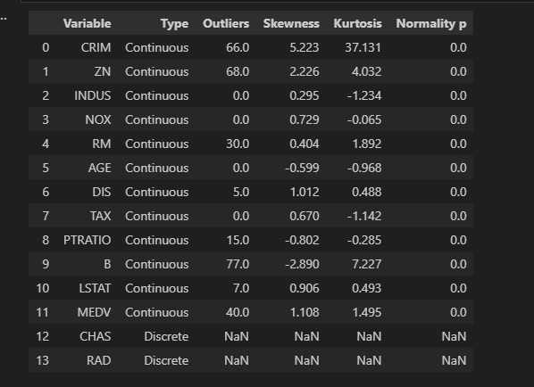

Normality: p-values are 0 for all continuous features, I mean none of them are normally distributed (important for OLS assumptions, not for tree models).
- Worst offenders (heavy skew + many outliers):
CRIM: 66 outliers, skew (5.22), kurtosis (37.13), the feature has extreme right-skew and very heavy tails.
ZN: 68 outliers, skew (2.23), the feature has strong right-skew and zero-inflation behavior.
B: 77 outliers, skew (-2.89), kurtosis (7.23), the feature has strong left skew and heavy tails.
Target also problematic:
MEDV: 40 outliers, skew 1.11, the feature target is right-skewed.
- Moderate skew:
DIS (skew 1.01), LSTAT (0.91), NOX (0.73), TAX (0.67).
- Discrete variables:
CHAS and RAD show NaN for skew/kurtosis/normality because they shouldn’t be treated as normal continuous distributions.
NOTE: there is missing values in Boston housing dataset

Bivariate Analyses:
Continuous features in contrast of target feature:
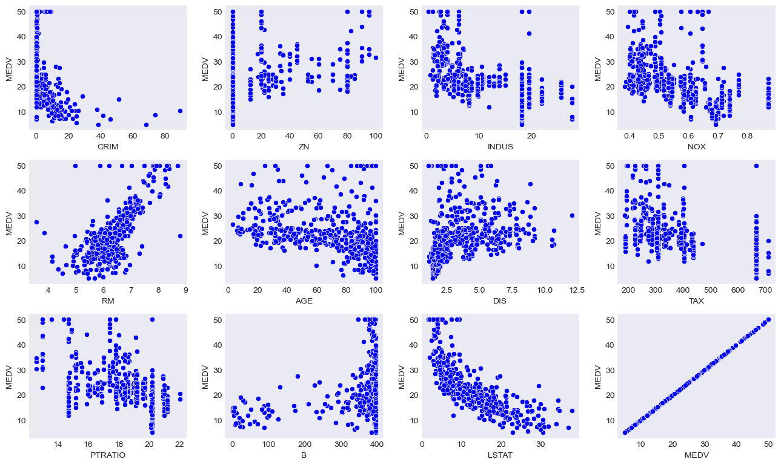
RM: Strong, linear positive relationship with MEDV. This feature should be retained as-is for all models.
LSTAT: Strong, non-linear negative relationship with MEDV. Consider applying a transformation (log/sqrt...) or using tree-based models to capture the non-linearity.
CRIM: Highly skewed with a non-linear impact on MEDV. Log transformation is recommended for linear models to address the skewness.
NOX: Monotonic negative relationship with MEDV, but it overlaps with other structural features. Best suited for regularized or tree-based models, rather than OLS.
INDUS: Moderate negative relationship with wide scatter. This feature is better suited for regularized or tree-based models than for OLS.
TAX: Moderate negative relationship with discrete patterns. More suitable for regularized or tree-based models.
PTRATIO: Moderate negative relationship with visible banding. Non-linear models are preferred for this feature.
DIS: Non-linear, diminishing-return relationship with MEDV. Transformation or tree-based models should be considered.
ZN: Zero-inflated with sparse signal, making it weak for linear models. Non-linear models can better handle this feature.
AGE: Weak, noisy negative trend. This feature has low priority unless used in combination with other predictors.
B: Weak and unstable relationship with MEDV. Best retained for non-linear models that can capture its effects more accurately.

Discrete features in contrast target feature:
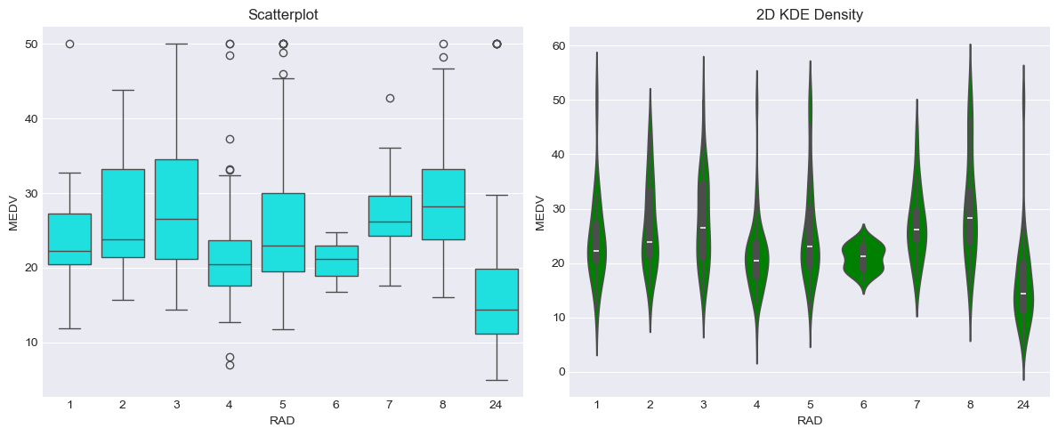
RAD vs MEDV:
Scatterplot: RAD shows discrete groupings, with higher values correlating to lower MEDV, but some high-value points at RAD = 24.
KDE Plot: Peaks show tight MEDV ranges for most RAD values, but RAD = 24 has a wider range with higher MEDV outliers.
- I will treat RAD as categorical and use tree-based models or transformations.
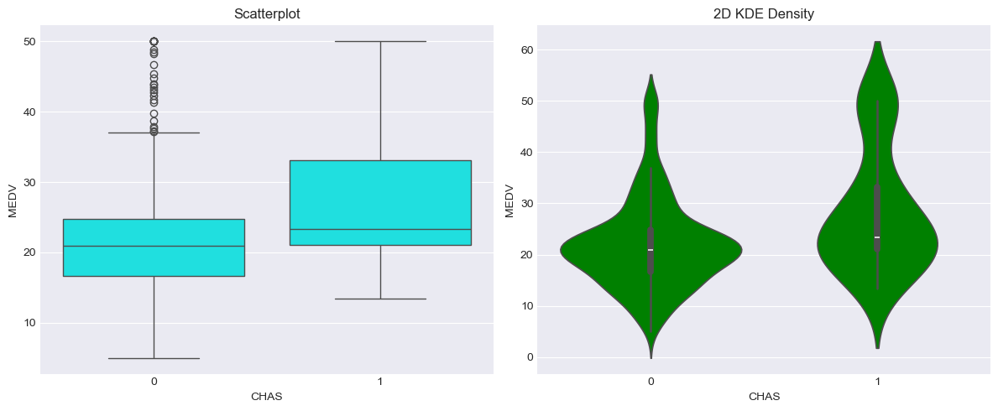
CHAS vs MEDV
Scatterplot: Homes near the river (CHAS = 1) tend to have higher MEDV than those further away (CHAS = 0).
KDE Plot: CHAS = 1 has a wider spread, indicating higher MEDV values.
Implication: Keep CHAS as a binary feature with no transformation.

Multivariate Analyses:
Multivariate correlation:
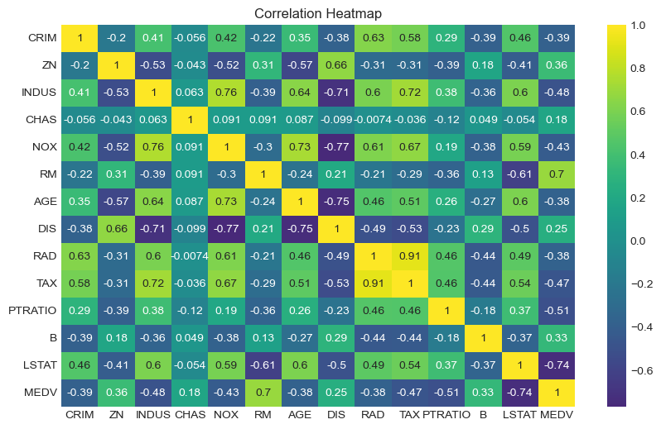
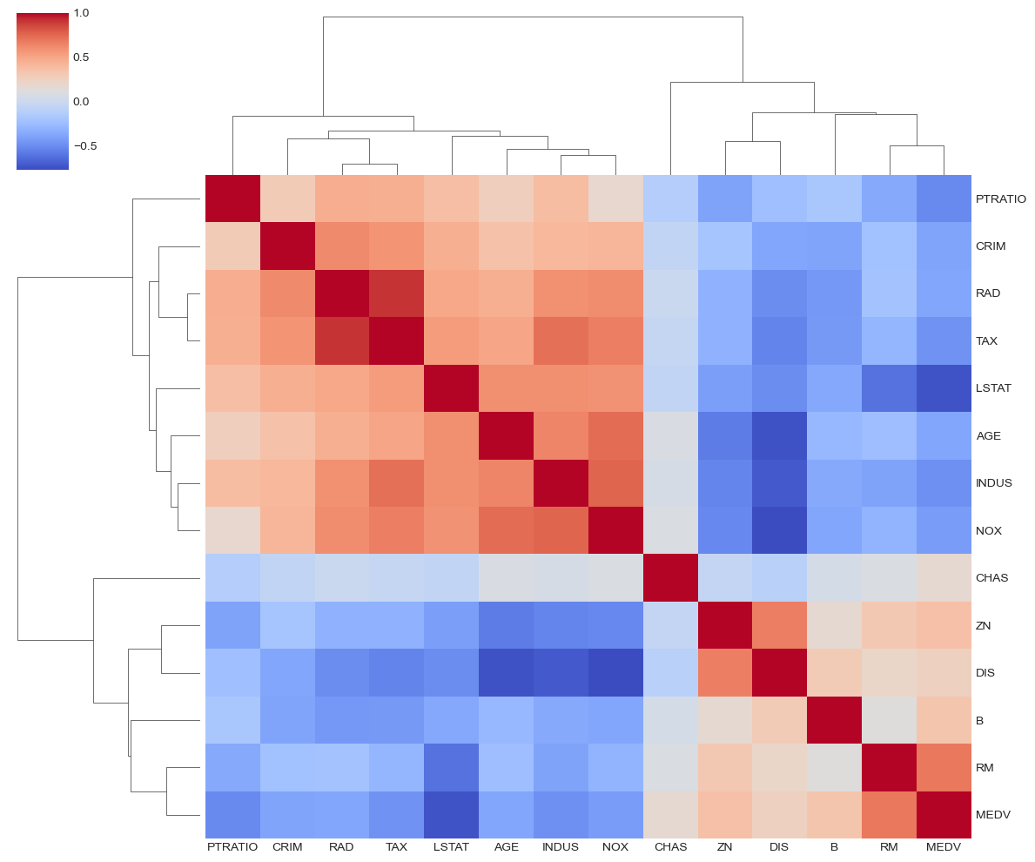
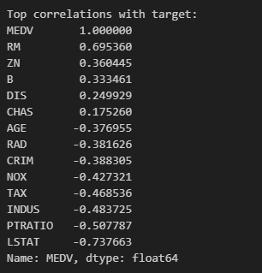
RM has the strongest positive correlation, while LSTAT has the strongest negative correlation with MEDV.
VIF ANALYSIS:
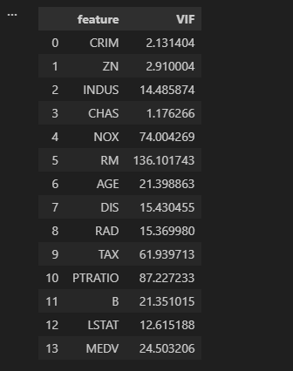
- Low VIF (<5):
CRIM (2.13), ZN (2.91), CHAS (1.18): These features show low multicollinearity and can be safely included in models without concerns of instability.
- High VIF (>10):
INDUS (14.49), DIS (15.43), RAD (15.37), AGE (21.40), B (21.35) these features show high multicollinearity and may need further analysis or dimensionality reduction.
- Very High VIF (>30):
NOX (74.00), RM (136.10), TAX (61.94), PTRATIO (87.23): These features exhibit severe multicollinearity, which could destabilize regression models. Consider removing, combining, or applying dimensionality reduction (PCA).

PCA:
- I used PCA in multivariate EDA to uncover the underlying variance structure, detect redundancy and multicollinearity among features, and visualize high-dimensional data in a reduced space without losing significant information.
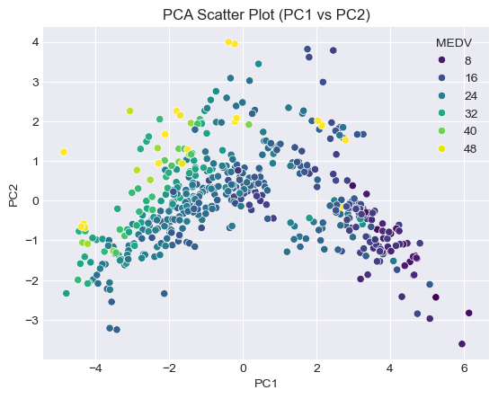
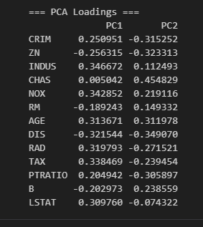
• PC1 represents socio-economic and environmental factors, primarily driven by features like CRIM (crime rate), NOX (pollution), LSTAT (percentage of lower status population), INDUS (industrial land), TAX (property tax rate), AGE (older homes), PTRATIO (pupil-teacher ratio), and RAD (accessibility to highways). PC1 is a strong predictor of MEDV, with higher values correlating to more affluent neighbourhoods. In contrast, features like ZN (large lots), RM (rooms per dwelling), DIS (distance to employment), and B (proportion of Black residents) have negative loadings, reflecting areas with lower MEDV.
• PC2 reflects geographic and infrastructural factors, strongly influenced by CHAS (proximity to the Charles River), NOX (pollution), AGE (older housing stock), and B (proportion of Black residents). CHAS stands out with a high loading, indicating its unique contribution to the variation in MEDV.
- Feature Engineering:
Plan:
I got to discover my features flaws-based data exploration and statistical analyses:
- the data split : val:15 %,test:15%,train:70%
- No imputation needed.
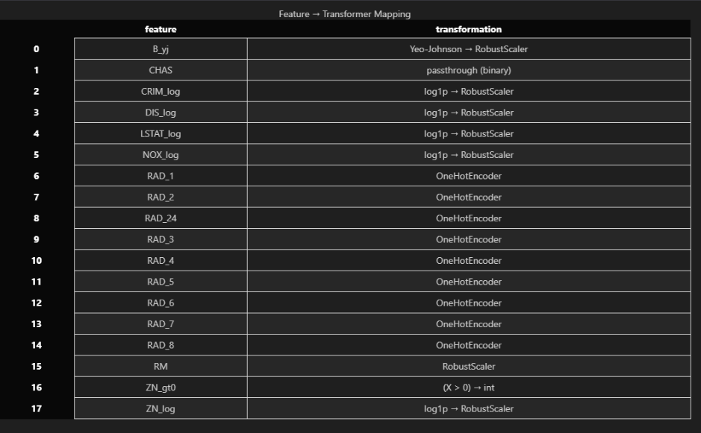
- the features that need transformation: 'CRIM', 'ZN', 'NOX', 'DIS', 'LSTAT',’B’.
Result:
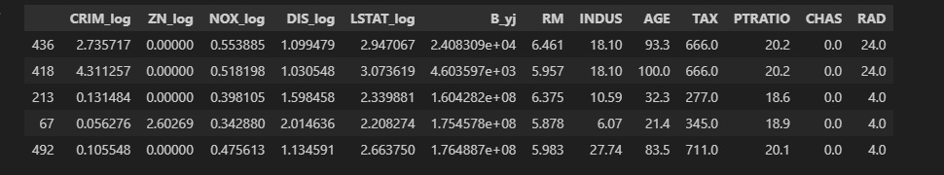
- the features that need encoding: ‘RAD’.
Result:
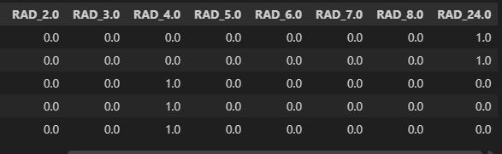
- the features that need Scaling: 'CRIM_log', 'ZN_log', 'NOX_log', 'DIS_log', 'LSTAT_log', 'B_yj', 'RM'.
Result:
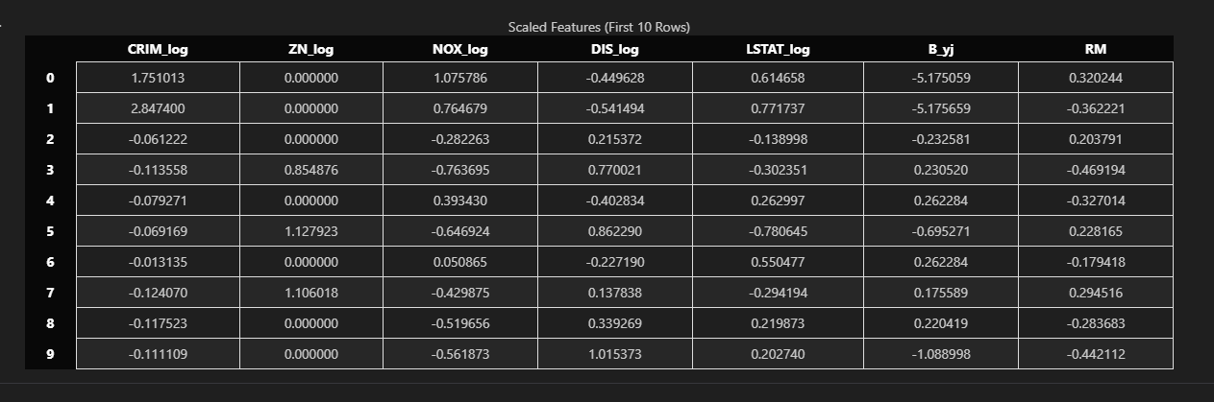
BaselineModeling :
- As of the baseline model, I have chosen to use these:
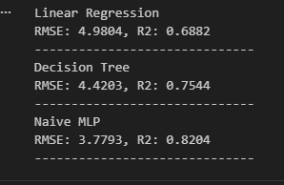

- Advanced Modeling :
feature importance:
- Based on given results. I have decided to drop these columns: RAD_7, RAD_8 , ZN_log
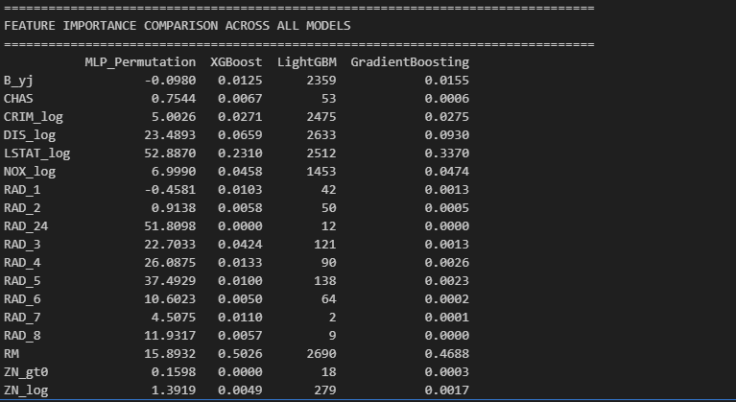
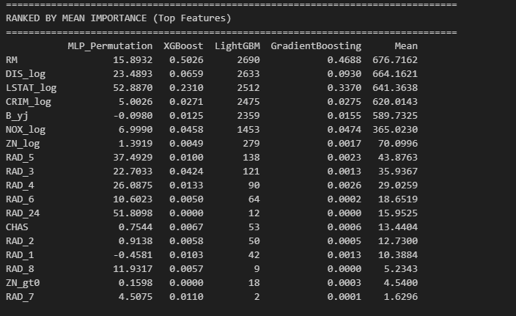

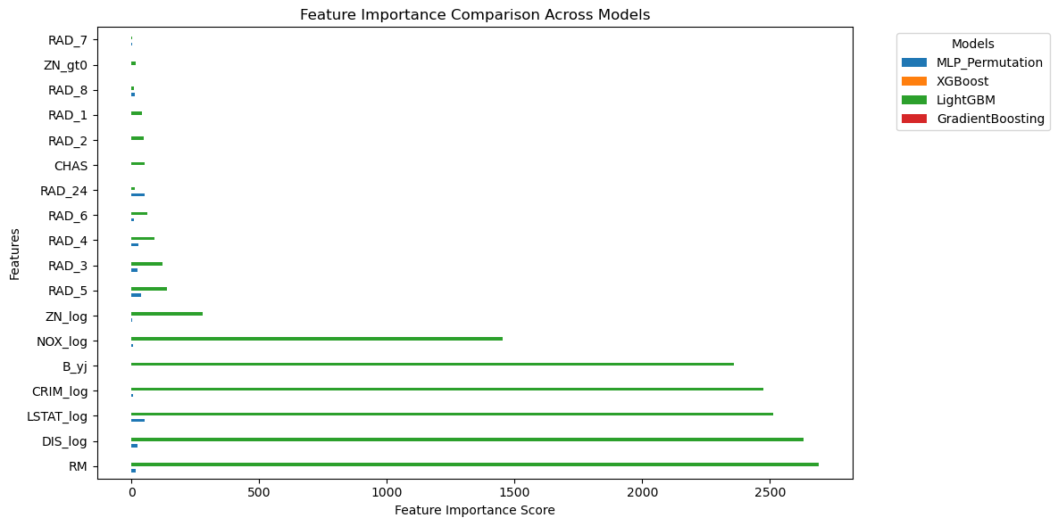
Hyperparameters
I used Optuna to tune the hyperparameters of my MLP model. I used Optuna to handled that . It tested different configurations and picked the one with the lowest cross‑validated MSE, which was 0.0428. The best setup ended up being a 3‑block residual network with 92 hidden units, around 0.11 dropout, a learning rate of 0.00294, and a small weight decay. After getting these parameters, I retrained the model on the full training set, and the final validation MSE dropped to 0.03399. This shows that the optimized model benefits from more data and generalizes nicely.

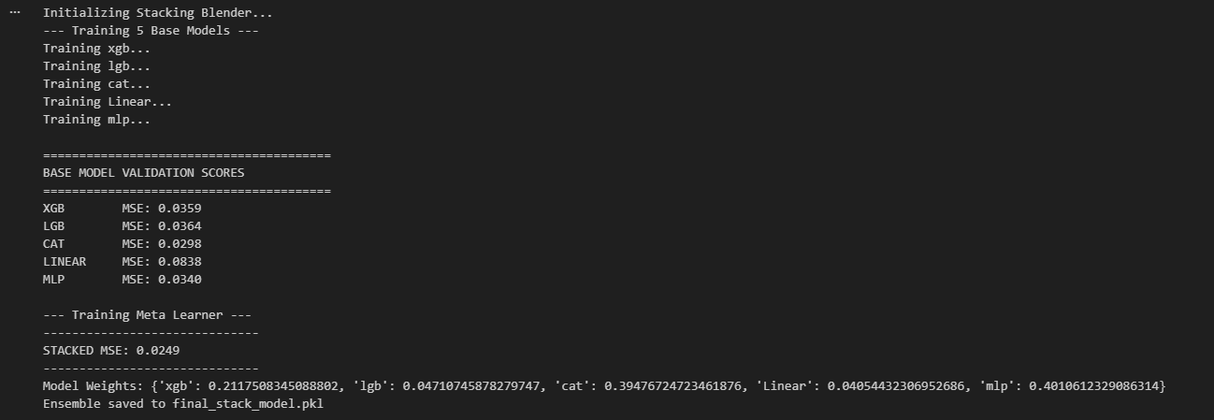
- I think no single model fully captures the data structure.
Although CatBoost and the MLP perform best individually, their errors are not perfectly aligned.
The stacking model exploits this complementarity to reduce validation MSE to 0.0249.
The learned weights confirm reliance on CatBoost and the MLP, with XGBoost adding secondary signal.

- Evaluation:
Learning curves :
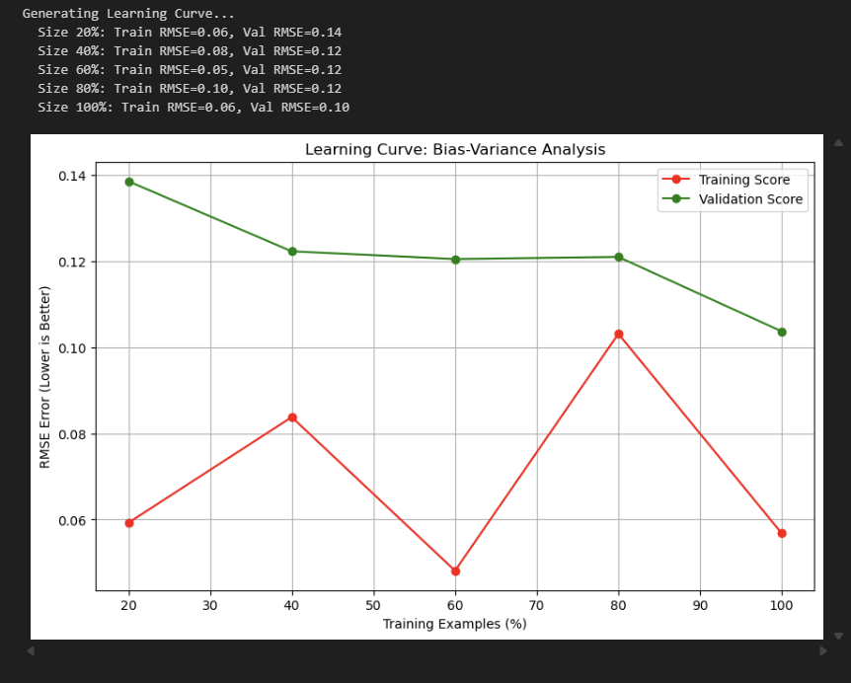
- the learning curve indicates rapid early learning: at 20% data, the model underfits (val error 0.14), but by 40% data, validation error stabilizes near 0.12. Additional data beyond 40% yields minimal improvement, showing diminishing returns. Training error stays low throughout, confirming good fit. The consistent small gap suggests low bias, moderate variance,o severe overfitting, but generalization plateaus early.

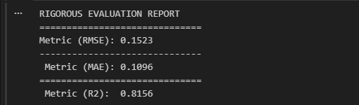
- RMSE ($3.43): On average, predictions deviate by about $3.43. I use RMSE as the primary metric because it penalizes larger errors more aggressively.
- MAE ($2.78): The typical absolute error is lower, around $2.78. The gap between MAE and RMSE indicates a small number of larger errors, but no severe outliers.
- R² (0.82): The model explains roughly 82% of the target variance, indicating it captures most of the underlying signal in the data.
I have chosen these metrics for the reason:
- RMSE is the primary metric because it emphasizes large errors, which are more critical in housing price regression.
- MAE reflects the typical prediction error and provides robustness against outliers.
- The RMSE–MAE gap indicates whether errors are evenly distributed or dominated by a few large deviations.
- R² is included to assess how much of the target variance the model explains.
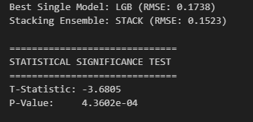
- Stacking ensemble (RMSE: 0.1523) beats the best single model LightGBM (RMSE: 0.1738) by 12.4%. Statistical test confirms this improvement is real, not random chance. The extremely low p-value (0.000436) provides >99.9% confidence stacking is genuinely better.

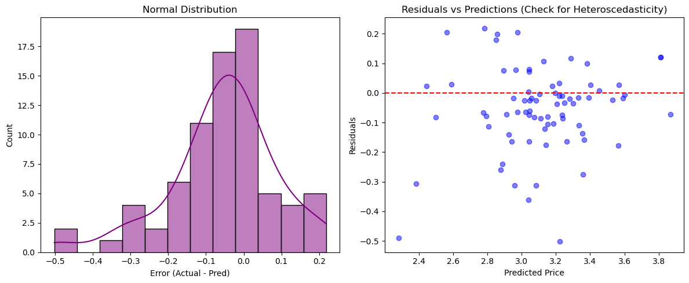
- Left Plot (Error Distribution):
The errors are normally distributed and centered around 0 in log space. Most errors fall within ±0.3 log units, showing no systematic bias.
- Right Plot (Residuals vs Predictions):
The scatter is random with no funnel shape, indicating homoscedasticity. The model's error variance is consistent across all predicted price ranges in log space.
Takeaway: the model is well-specified and statistically valid.
- Interpretation and Explainability
- Declaimer: Although final performance is reported using a stacked ensemble, global interpretability analysis is conducted on the base learners.
This allows examination of how different model classes (tree-based vs neural) capture relationships between input features and the target.
The stacking layer operates on model predictions rather than original features and is therefore not directly interpretable in feature space.

- Global explanations: SHAP:
- SHAP for LightGBM:
- 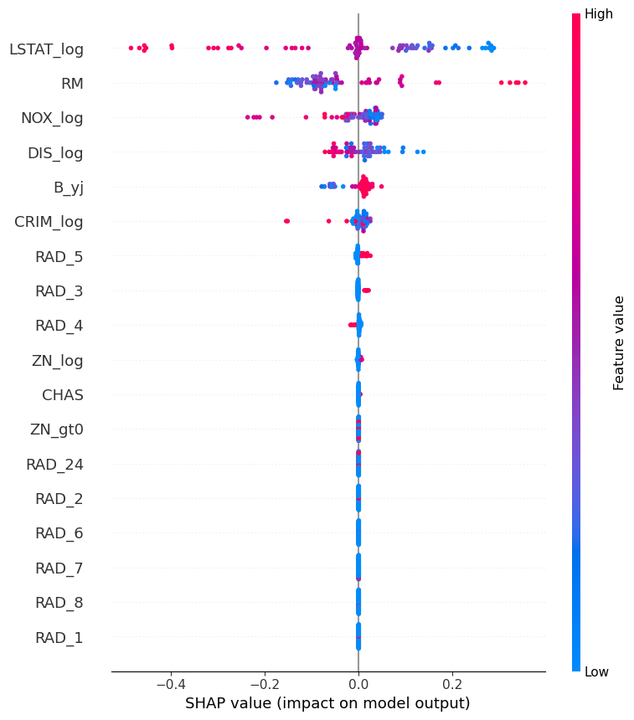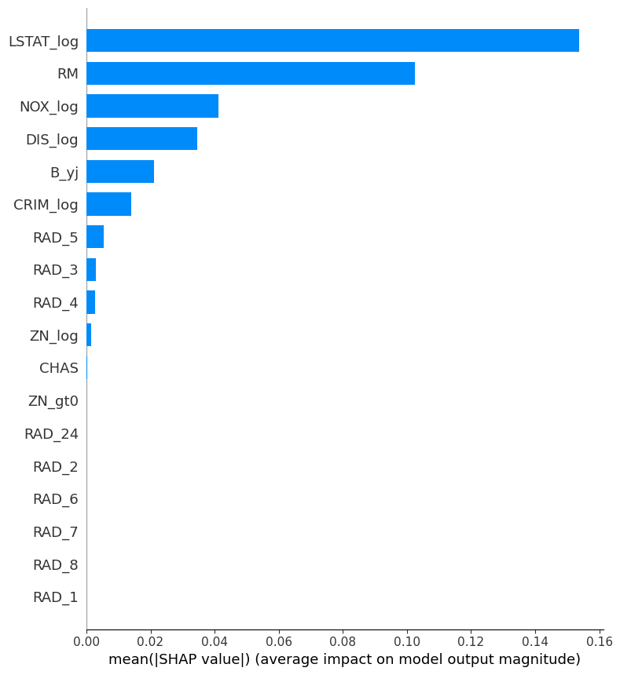
- LightGBM relies mainly on LSTAT_log and RM as global drivers, with LSTAT_log exerting a strong negative effect and RM providing a consistent positive contribution.
- The SHAP spread indicates that the model captures non-linear interactions across features.
- Categorical variables such as RAD show near-zero SHAP values, implying minimal influence.Overall, low LSTAT_log values act as a strong positive signal, while housing size drives
- SHAP for Cat :
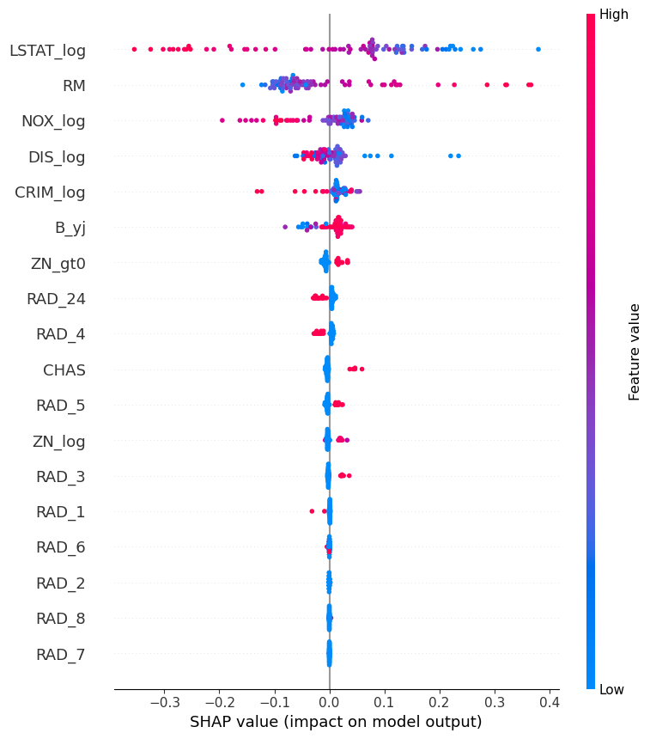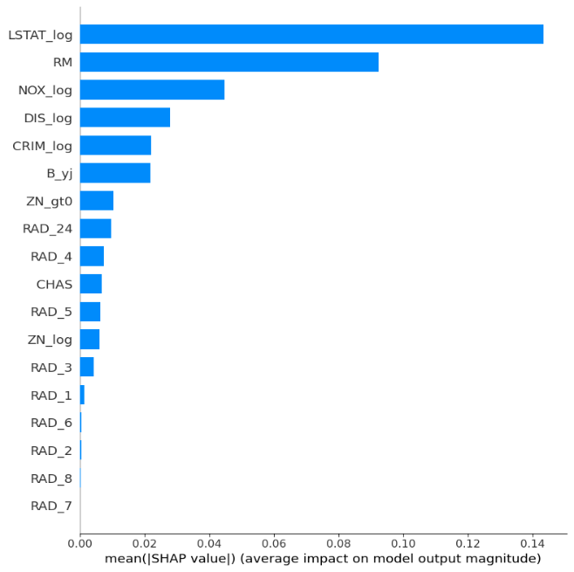
- LSTAT_log and RM emerge as the most influential features in my model: higher poverty levels clearly reduce predictions, while an increase in the number of rooms raises them.
- NOX_log and CRIM_log consistently show negative effects, with higher pollution and crime levels leading to lower predicted values.
- Distance to employment centers (DIS_log) also plays a role, as greater distances generally correspond to reduced predictions.
- The wide SHAP distribution for LSTAT_log indicates that it drives the largest variation across individual predictions.
- Categorical variables such as RAD and CHAS have relatively small impacts, suggesting the model focuses more on structural and environmental factors.
- Shap for mlp:
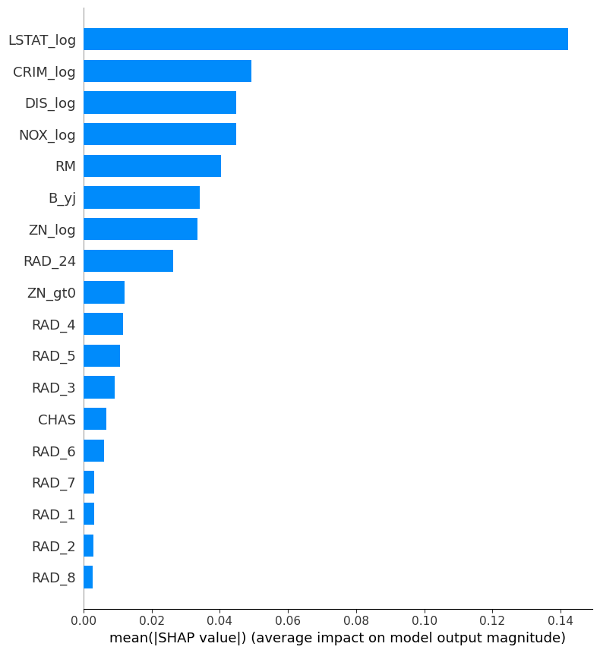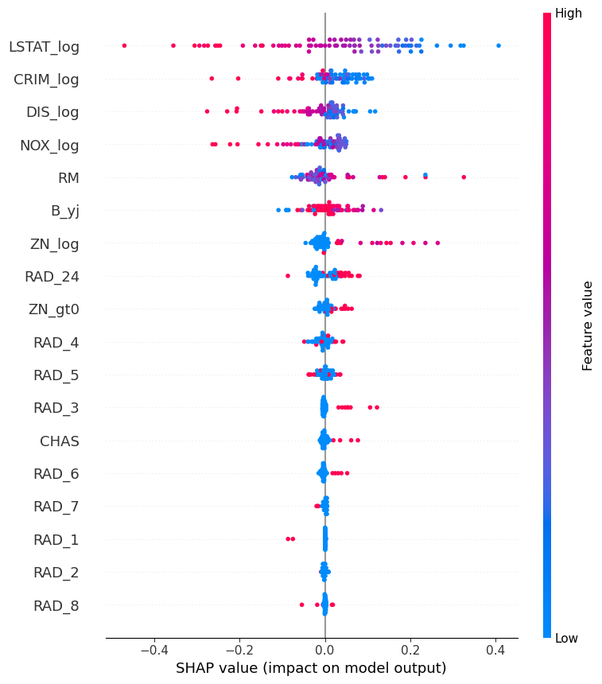
- STAT_log remains the most critical feature in my model, with higher values strongly pushing predictions downward.
- In this MLP, CRIM_log and DIS_log move up to the second and third most important features.
Compared to my previous CatBoost model, RM (number of rooms) plays a noticeably smaller role here.
- NOX_log shows a clear and consistent negative effect, indicating the network’s sensitivity to environmental pollution.
- RAD_24 stands out as the only categorical feature with substantial influence, ranking well above variables like CHAS.
Overall, the MLP distributes importance more evenly across the top features rather than concentrating it heavily in one or two.

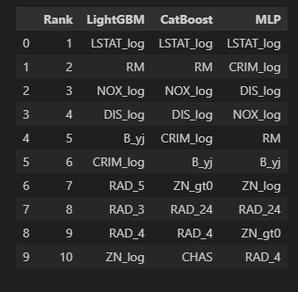
- Top predictor: LSTAT_log dominates across all models, clearly carrying the strongest signal in the data.
- Tree alignment: LightGBM and CatBoost show very similar top features (RM, NOX_log), which is expected given their shared gradient-boosted tree structure and interaction modeling.
- Model divergence: The MLP departs in lower rankings, elevating CRIM_log and DIS_log over RM, reflecting its different inductive bias on continuous features.
- Feature engineering impact: The consistent use of log, Yeo-Johnson, and gt0 transformations was critical in unlocking non-linear structure and improving performance across all models.
- Local explanations on several representative examples.

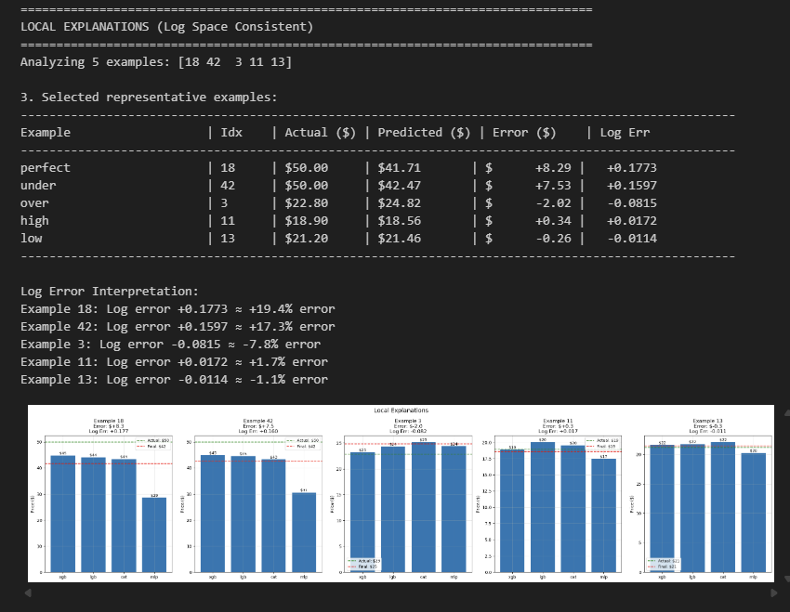
- This model performs well for typical values (±2% error at ~$20) but has a clear weakness: it systematically underpredicts higher-priced items (~$50) by 17–19%. Log-space error confirms consistent bias. It is reliable for mid-range predictions but needs calibration or enriched features for premium items before full deployment. A tiered modeling approach is recommended.

- Conclusion
Well this end-to-end project resulted in a strong stacked ensemble pricing model, achieving solid performance with an R² of 0.82 and an RMSE of 0.15. Drawing on couple years of hands-on experience and EDA-driven feature engineering, model stacking provided statistically meaningful improvements over individual models. However, local interpretation exposed a consistent underprediction for higher-priced items (around $50). While the model is reliable and production-ready for mid-range pricing, I think it can be improved much better if I added much tiered Calibration and tweak resources given, the dataset size limits its parks. I have made sure to include all requirements given and more

Thank you for giving me the opportunity to practice my knowledge!

